**TEMA 5**

--toate exercitiile afiseaza numele echipei si numele fiecarui membru din staff-ului

**Ex 10.1.a**

declare

v_echipa echipa.nume_echipa%type;

v_id echipa.id_echipa%type;

v_nume_staff staff.nume_staff%type;

cursor ec is

select id_echipa, nume_echipa

from echipa

where id_echipa in (1,3,5,8);

cursor st(id number) is

select nume_staff

from staff

where id_echipa = id;

begin

open ec;

loop

fetch ec into v_id,v_echipa;

exit when ec%NOTFOUND;

dbms_output.put_line('Echipa '||v_echipa || ' e formata din:');

open st(v_id);

loop

fetch st into v_nume_staff;

exit when st%NOTFOUND;

dbms_output.put(' ' || v_nume_staff);

end loop;

close st;

dbms_output.put_line('');

end loop;

close ec;

end;

/

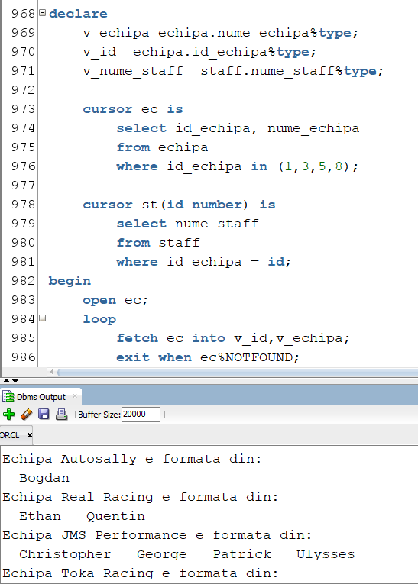

**Ex 10.1.b**

declare

v_echipa echipa.nume_echipa%type;

v_id echipa.id_echipa%type;

v_nume_staff staff.nume_staff%type;

cursor ec is

select id_echipa id, nume_echipa nume_ec

from echipa

where id_echipa in (1,3,5,8);

cursor st(id number) is

select nume_staff nume_st

from staff

where id_echipa = id;

begin

for i in ec loop

dbms_output.put_line('Echipa '||i.nume_ec || ' e formata din:');

for j in st(i.id) loop

dbms_output.put(' ' || j.nume_st);

end loop;

dbms_output.put_line('');

end loop;

end;

/

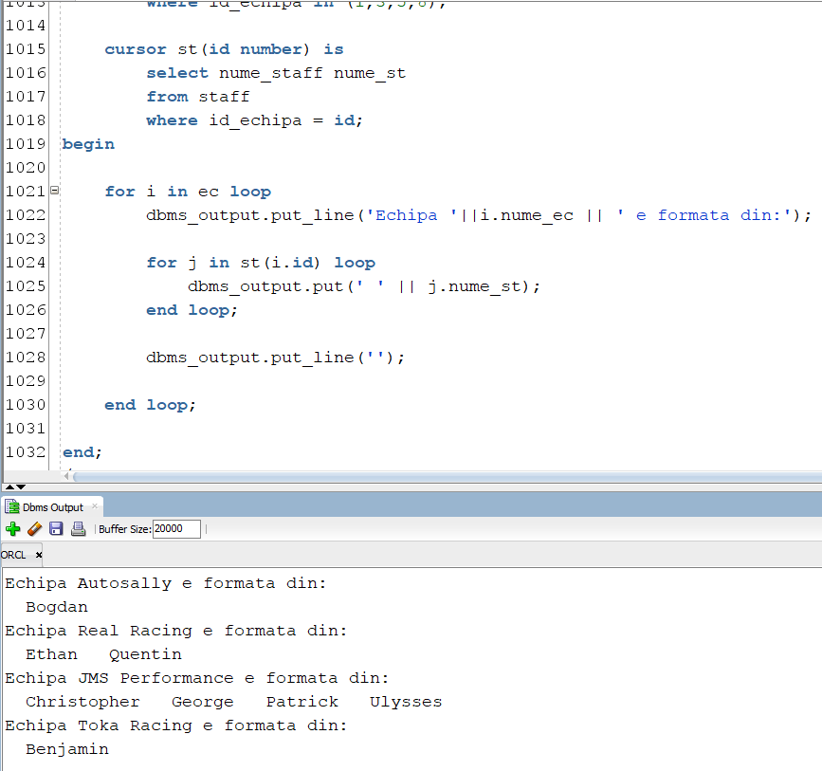

**Ex 10.1.c**

begin

for ec in (select id_echipa id, nume_echipa nume_ec

from echipa

where id_echipa in (1,3,5,8))

loop

dbms_output.put_line('Echipa '||ec.nume_ec || ' e formata din:');

for st in (select nume_staff nume_st

from staff

where id_echipa = ec.id)

loop

dbms_output.put(' ' || st.nume_st);

end loop;

dbms_output.put_line('');

end loop;

end;

/

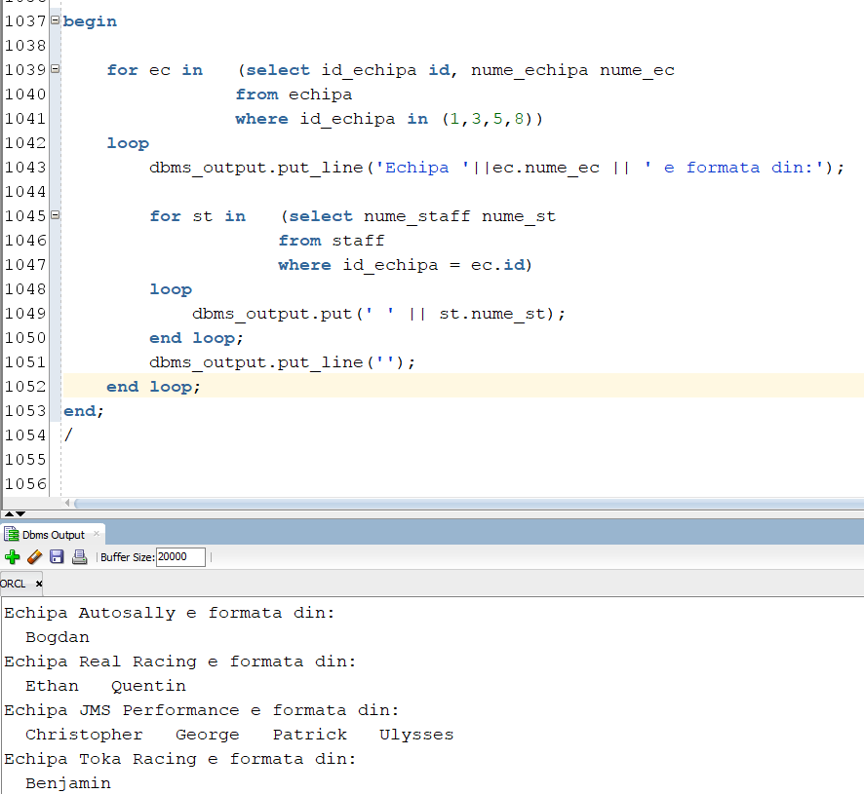

**Ex 10.2**

declare

type refcursor is ref cursor;

cursor ec is

select e.nume_echipa,

cursor (select s.nume_staff

from staff s

where s.id_echipa = e.id_echipa)

from echipa e

where e.id_echipa in (1,2,3,4,5,6,7,8);

v_echipa echipa.nume_echipa%type;

v_cursor refcursor;

v_staff staff.nume_staff%type;

begin

open ec;

loop

fetch ec into v_echipa,v_cursor;

exit when ec%NOTFOUND;

dbms_output.put('Echipa '||v_echipa || ' are membrii:');

loop

fetch v_cursor into v_staff;

exit when v_cursor%notfound;

dbms_output.put(v_staff||' ');

end loop;

dbms_output.put_line('');

end loop;

end;

/

